Data Engineering Foundations & Databricks
Part 1: What Is Data Engineering?
Data engineering is the practice of designing and building systems for collecting, storing, and analyzing data at scale. While data scientists and analysts look for insights after the data is ready, data engineers build the robust pipelines and plumbing that make that data clean, accessible, and trustworthy in the first place.
2.What a Data Engineer Does
Builds data pipelines, ensures data flows smoothly from source systems to storage, transforms raw data into structured formats, and maintains data warehouse architectures.
3.Where Data Comes From
User clicks on websites, IoT sensor logs, mobile app transactions, payment gateways, customer service logs, and third-party APIs.
4.Real-World Example (E-Commerce / Food Delivery): Imagine ordering a meal on a delivery app like Swiggy or Zomato. The moment you tap “Place Order,” multiple data events occur: your payment goes through a gateway, a notification is sent to the restaurant tablet, and GPS coordinates update your delivery partner’s route. A data engineer writes code to capture these raw event streams, clean up missing user IDs, merge them with inventory tables, and load them into a centralized database so management can track hourly sales trends on a dashboard.
Part 2: Why Do We Need Data Engineering?
Without data engineering, a company’s data is essentially a digital landfill — scattered across various apps, filled with duplicates, missing values, and formatting errors. If leadership tries to build business reports on top of unmanaged data, they face severe consequences.
2.Risks of Bad Data
Inaccurate revenue reports, miscalculated inventory stock leading to stockouts or overstocking, and flawed marketing campaigns targeting the wrong audience.
3.Why Data Quality Matters
High data quality ensures that data is accurate, complete, consistent, and timely. Reliable data builds trust across departments.
4.Role of Data Pipelines
Automated data pipelines extract data from source apps, transform/clean it in transit, and load it into analytics platforms (ETL), ensuring business intelligence tools always display up-to-date metrics.
Part 3: Data Engineer vs. Data Analyst & Architecture Models
Who prepares vs. who analyzes?
The Data Engineer prepares, structures, and maintains the data pipelines and infrastructure. The Data Analyst takes that prepared data to analyze trends, build dashboards, and answer specific business questions (e.g., “Why did sales decline last month?”).
Collaboration: When a retail company sees declining sales, the Data Engineer ensures all point-of-sale and web traffic logs are accurately flowing into the data warehouse. The Data Analyst then queries that data to discover which specific product categories or regions experienced the drop.
Comparison Table: Data Engineer vs. Data Analyst
DimensionData EngineerData Analyst
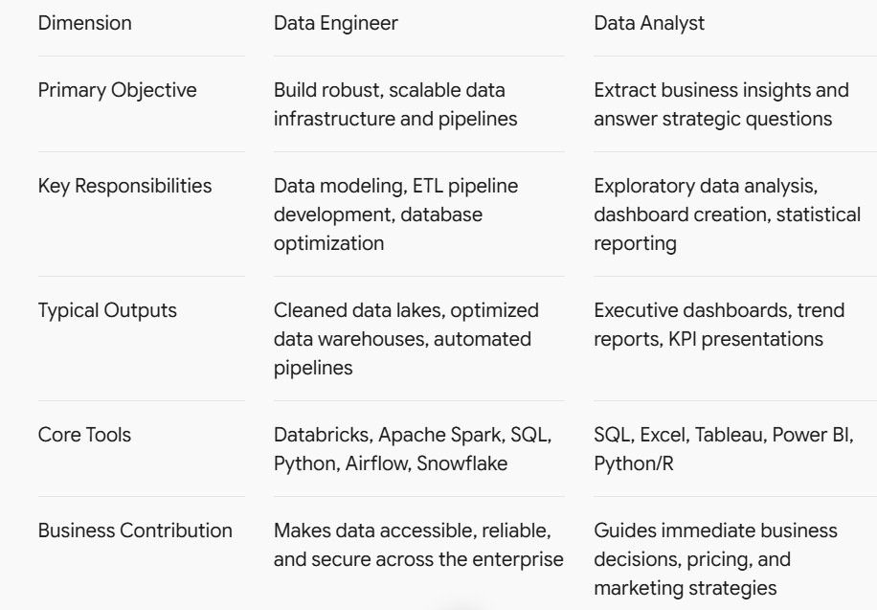
- For your technical depth, it is also helpful to distinguish between database transaction systems and analytical systems:
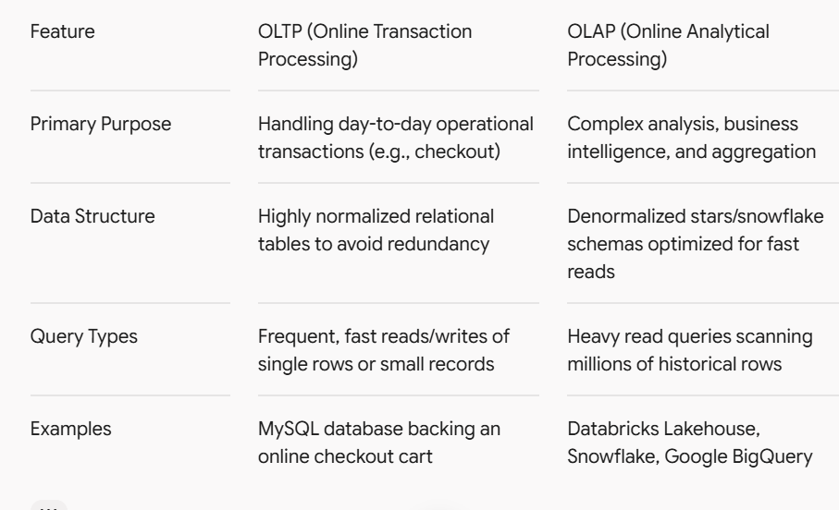
Part 4: Getting Started with Databricks
Databricks provides a unified analytics platform built on top of Apache Spark, allowing data teams to handle data engineering, machine learning, and business analytics in one collaborative environment.
A. Databricks Workspace
A collaborative web-based environment where data teams organize files, manage cluster compute resources, write notebooks, schedule pipelines, and share dashboards. Resources include notebooks, libraries, data tables (Unity Catalog), and job schedulers.
B. Compute
Compute refers to the underlying CPU and memory processing power configured in clusters to execute code. Notebooks and pipelines require heavy compute because processing terabytes of data exceeds a standard laptop’s capacity.
Real-world analogy: Writing code in a notebook is like writing a blueprint for a highway network on paper; compute is the heavy machinery (bulldozers, cranes, and workers) brought in to actually build the highway.
C. Databricks Notebooks
An interactive web-based document that combines executable code cells (SQL, Python, Scala, R), markdown text explanations, and visual charts. Beginners use notebooks to step-by-step load sample datasets, filter rows, inspect dataframes, and render visualizations interactively.
- Here is a simple, beginner-friendly architecture diagram to help readers visualize how data flows from its raw origin all the way to business insights:
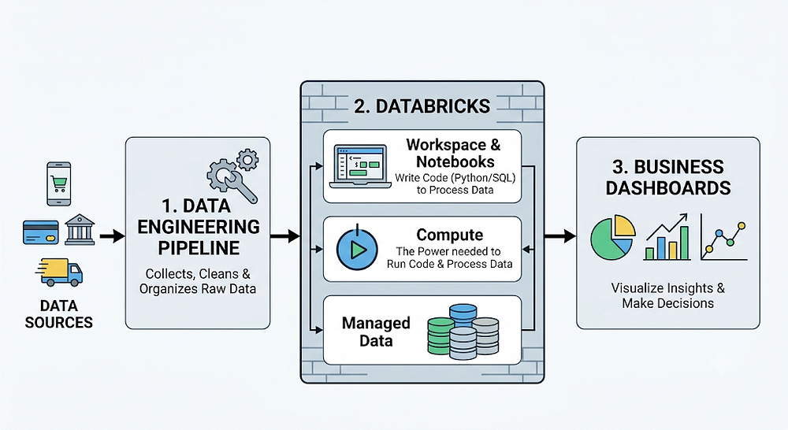
How to Read This Diagram (Step-by-Step for Blog):
- Data Sources (Where data starts): Every day, user interactions generate raw data — like mobile app clicks, website page views, online purchases, and payment transactions.
- Ingestion & Pipelines (The plumbing): Automated data pipelines collect this scattered, messy data and transport it safely into a centralized storage space.
- Databricks Processing (The kitchen): Inside the Databricks Workspace, compute clusters and notebooks run code to clean, filter, structure, and organize the raw records into reliable tables.
- Business Dashboards (The final result): Finally, clean and structured data flows into BI dashboards (like Power BI or Tableau) so business leaders can track performance and make smart decisions.

